# Quicksort Algorithm: Implementation, Analysis, and Randomization

**Author:** Mahesh Gaire
**Course:** Algorithms and Data Structures (MSCS-532-B01)
**Date:** 11/16/2025

## Abstract
This report presents deterministic and randomized Quicksort implementations, theoretical analysis, and empirical evaluation.

## Implementation Overview
- Deterministic Quicksort: pivot = middle element
- Randomized Quicksort: pivot chosen randomly

## Time Complexity
Case | Deterministic | Randomized
Best | O(n log n) | O(n log n)
Average | O(n log n) | O(n log n)
Worst | O(n²) | O(n log n) expected

## Empirical Results
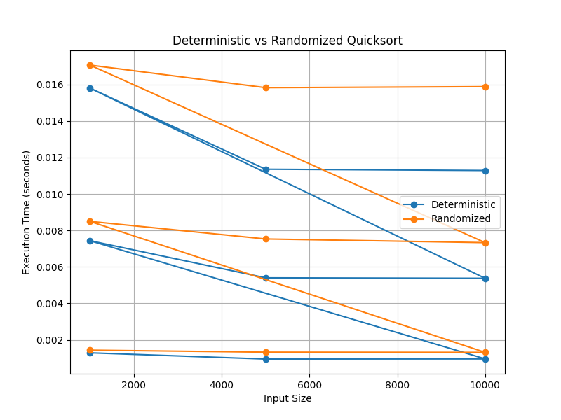

Observations:
- Randomized Quicksort performs consistently across all input types.
- Deterministic Quicksort is slower on sorted or reverse-sorted arrays.

## Conclusion
Randomized Quicksort is preferable for unpredictable input data, ensuring near O(n log n) performance.

## References
- Cormen, T. H., et al. *Introduction to Algorithms* (3rd ed., 2009).
- Sedgewick, R., & Wayne, K. *Algorithms* (4th ed., 2011).
- Mitzenmacher, M., & Upfal, E. *Probability and Computing* (2005).

